Data lab 3 - Meta-analysis
Question 1: Check the output log, how many markers did the meta-analysis complete? Which is the marker with the smallest p-value?
2230666; 'rs173539'.
Question 2: Quickly inspect the loaded result, how many number of rows and columns are there? Does the number of rows match the number of markers scanned in the meta-analysis? What does the number of SNPs imply about the reference panel that was used for imputation?
dim(meta_result)
2230666 rows, 15 columns. Yes, it matches. It strongly suggests that at least one or more of the contributing studies used the HapMap Phase 2 (HapMap2) reference panel for imputation. It is was widely used in early GWAS.
Question 3: Which column should be look at for the p-values?
P.value
Question 4: Upload your QQ-plot to the report. What conclusions does the QQ plot tell?
png(file="qq-meta.png", width=85, height=85, units="mm", res=300)
par(mfrow = c(1, 1))
par(mar=c(5,5,1,1))
qq(meta_result$P.value, pch=18, col="blue" ,cex = 0.45, las = 1, cex.axis = 0.6, cex.lab = 0.8)
dev.off()
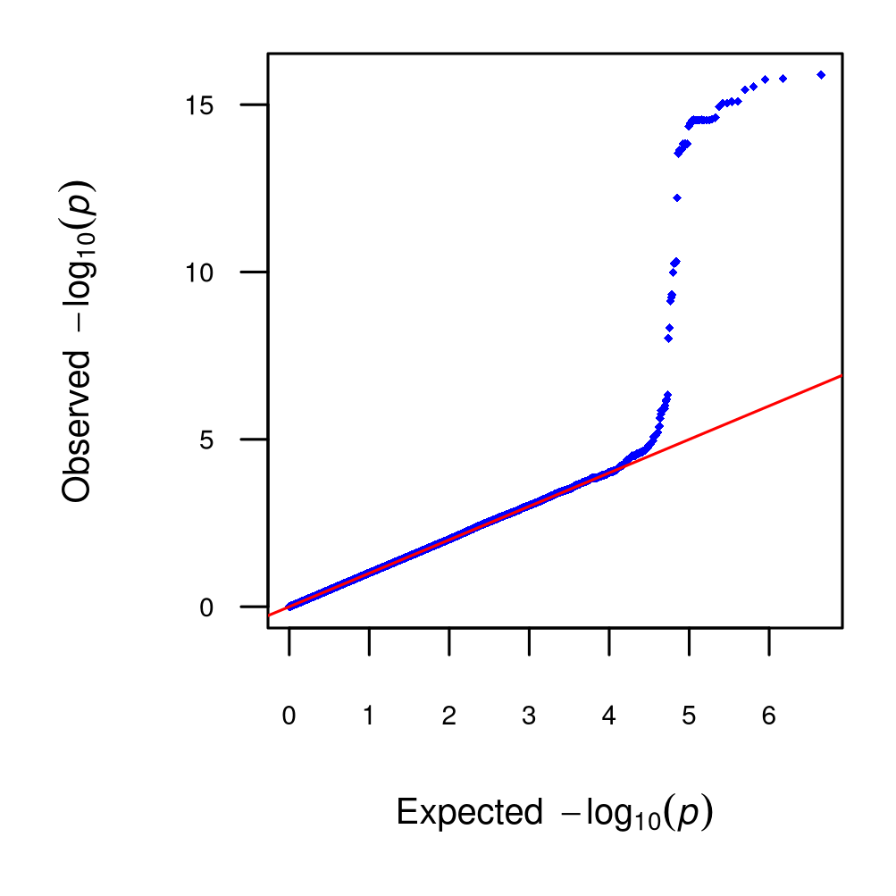
There are more variants with low p-values in the region than in the single study, and the lowest p-value is much lower than in the single study, so it is likely a true association.
Question 5: Upload your Manhattan plot to the report.
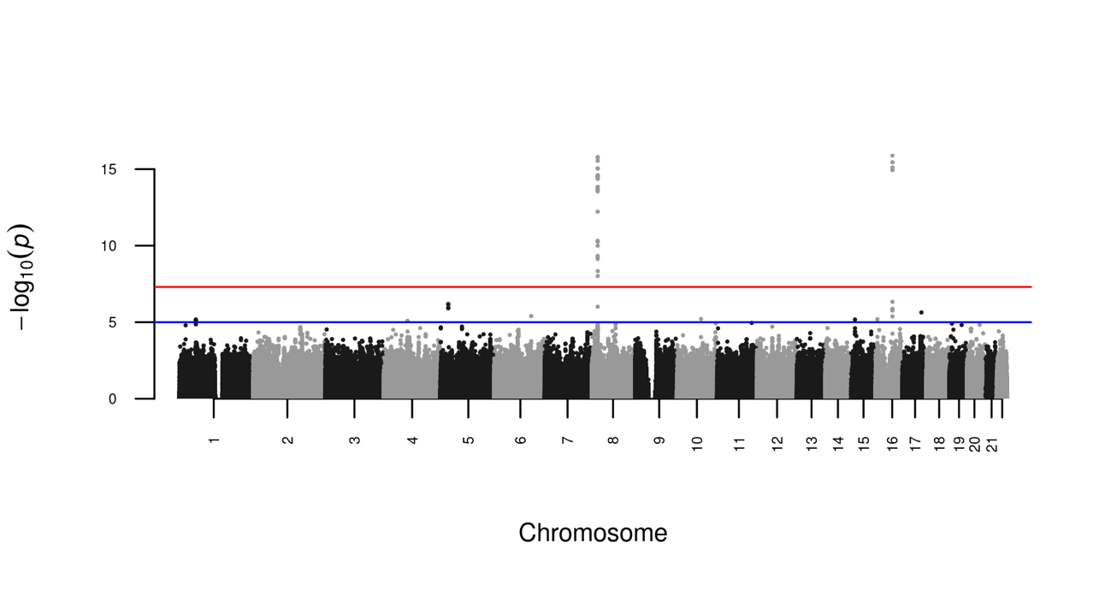
Question 6: Use LocusZoom to make the regional plot for the top SNP and upload it to the report.
for_locus_zoom <- merged_result[which(merged_result$pos>56900000&merged_result$pos<57100000&merged_result$chr==16),]
for_locus_zoom <- for_locus_zoom[order(for_locus_zoom$pos),]
ID_chr_pos <- paste(for_locus_zoom$chr, for_locus_zoom$pos, sep=":")
for_locus_zoom <- cbind(for_locus_zoom, ID_chr_pos)
write.table(for_locus_zoom, file="extracted_meta.txt", row.names=FALSE, col.names=TRUE, sep="\t", quote=FALSE)
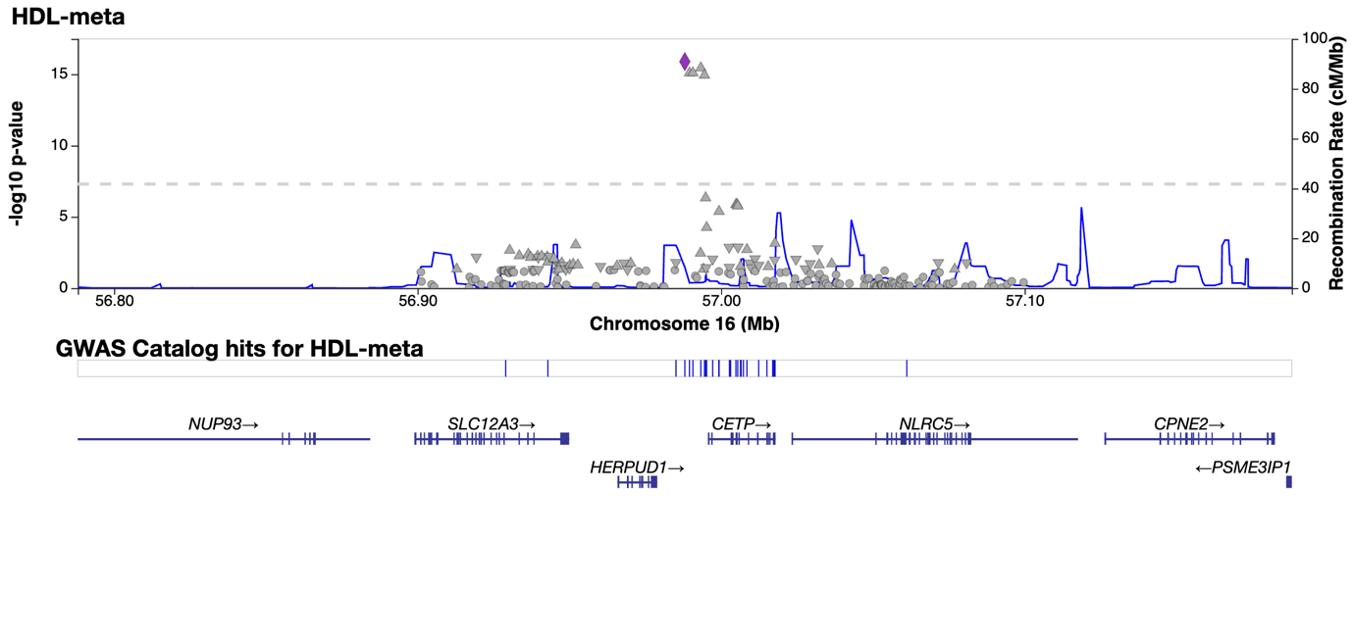
Question 7: Do you see any difference in the significance? What would you conclude for the CETP gene and its association with HDL levels?
for_locus_zoom[which(for_locus_zoom$P.value==min(for_locus_zoom$P.value)),]
In single study, the p-value was 9.172e-10; in meta-analysis, the p-value is 1.287e-16. From the plots, we can see the peak is higher in the meta-analysis than in the single study. Therefore, the CETP gene is likely a true association with HDL levels.

Extra exercise: Have a quick look at the regional plot: do the combined results agree with the lab's results regarding which gene is likely causal?
CETP is also flagged by rare variant analyses for HDL using the largest datasets to date, so variants that affect this protein function likely affect HDL levels.
Example:
